**E-Book Online System**



**E-Project**

**Group Members**

|  |  |
| --- | --- |
| **Student Name** | **Enrollment No** |
| **Mr.Furqan-ur-Rehman** | Student1311432 |
| **Mr. Hassan Mujtaba** | Student1311640 |
| **Mr. Farzam Ahmed** | Student1312165 |
| **Mr. Muhammad Wahaj** | Student1312214 |

**Faculty: Miss Muniba Javed Khan**

**Batch Co-Coordinator: Miss Ariba Ali**

**Batch: 2104B1**

**Curriculum: OV-ACCP-PRIME (6740)**

**Acknowledge**

We would like to express our special thanks to our teacher (Miss Muniba Javed) as well as our institute (Aptech) who gave us golden opportunity to do this wonderful project on this topic (E-Book System), which also helped us a lot of research and we came to know about so many new things we are thankful to them.

Secondly, we should also like to thanks our batch coordinator (Miss Ariba Ali) and group member who have helped us a lot in finalizing this project within the stipulated time frame.

**Statement**

E-Book System is an online e-book store where anyone can easily buy books, participate in competitions. You can get the book in hard copy, pdf and CD. The Objective of this program is to give a sample project to work on real life projects. These applications help you build a larger more robust application.

The purpose of this website is to facilitate these people who like to buy and read books.

**Requirement Specification**

The Web Site is to be created based on the following requirements.

**Functional Requirements**

* A database should be created that holds the details of the books, orders, and that of the customers.
* The customers who are registered with the site will alone be able to fetch and see the details of the website.
* The Admin solely should have the rights of uploading the details of the books and as well uploading the books in the PDF document form.
* As soon as the receipt of an order, the customer should be acknowledged with the details of the order, like address (if ordered for the CD or Hard copy) and then ask for the confirmation of the order.
* After the confirmation is received from the user, then only the further process has to be taken place.
* The customer who has requested for the book online in the form of the PDF Document, can only access that document only after the payment is received by the publisher.
* The contact information is also needed to be provided, which includes the details of the dealers of that location, so that the customer can even purchase that book from the dealer.

**Hardware/ Software Requirements**

**Hardware**

* + - * A minimum computer system that will help you access all the tools in the courses is a Pentium 166 or better
      * 128 Megabytes of RAM or better

**Operating System**

* + - * LINUX / Windows 2000 Server (or higher if possible)

**Software**

* + - * PHP
      * MySQL
      * PERL
      * Apache

**ERD Diagram**

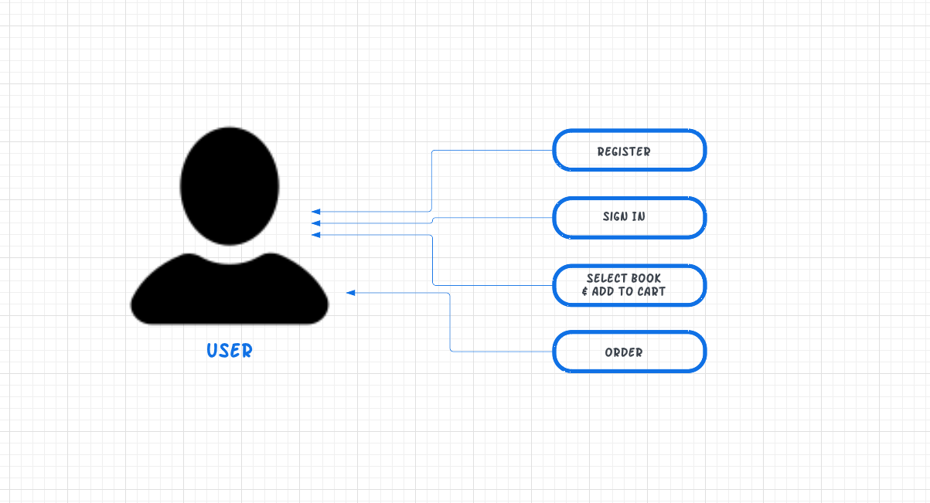

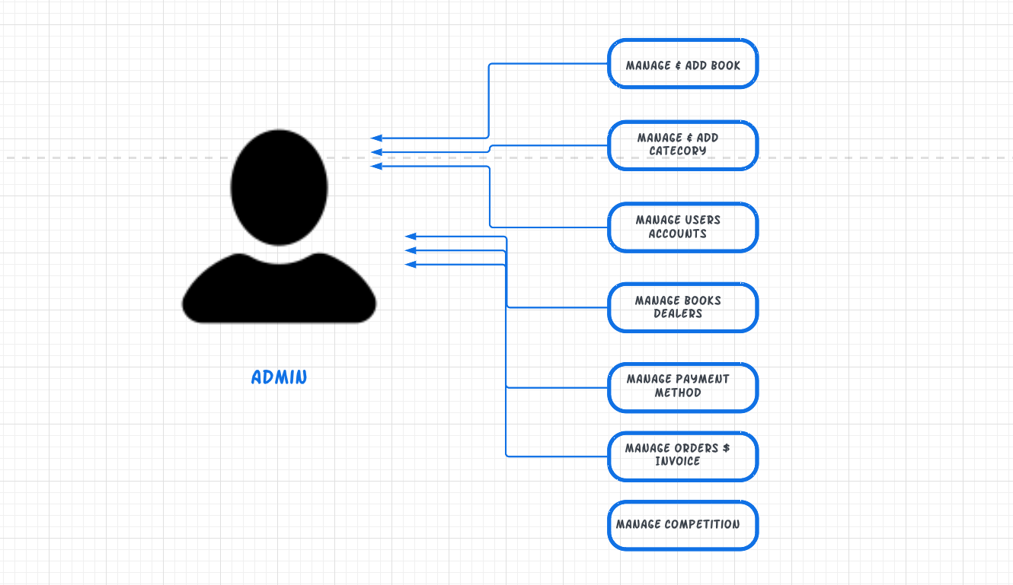

**Task Sheet**

|  |  |  |  |
| --- | --- | --- | --- |
| S# | Task | Team Member Name | status |
| 1. | Analysis | Hassan Mujtaba  Muhammad Wahaj  Furqan ur Rehman | ✓ |
| 2. | Design | Hassan Mujtaba  Furqan ur Rehman | ✓ |
| 3. | Development | Hassan Mujtaba  Muhammad Wahaj Furqan ur Rehman | ✓ |
| 4. | Documentation | Muhammad Wahaj  Farzam Ahmed | ✓ |
| 5. | Finalization | Hassan Mujtaba  Muhammad Wahaj  Farzam Ahmed  Furqan ur Rehman | ✓ |

**SUBMISSION CHECKLIST**

|  |  |  |  |
| --- | --- | --- | --- |
| S.no | List of items | Remarks | Comments |
| **1.** | Do All Pages Linked  together | **Yes** | ✓ |
| **2.** | Authorization | **Yes** | ✓ |
| **3.** | Crud Operations | **Yes** | ✓ |
| **4.** | Database Connection | **Yes** | ✓ |
| **6.** | Cart System | **Yes** | ✓ |
| **7.** | Project Zip File | **Yes** | ✓ |

**Task Review Sheet 1**

|  |  |  |  |  |  |  |
| --- | --- | --- | --- | --- | --- | --- |
| Project Ref. No.: Advertisement Portal Management System/01 | | Project title | Date of Preparation of Activity Plan | | | |
| No | Task | E-Book System | Actual | Actual | Team-mate | Status |
| Start Date | Days | Names |
| 1 | Create Database | 22/11/22 | 1 | Furqan-ur Rehman,  Hassan Mujtaba | Complete |
| 2 | Design Admin Panel | 23/11/22 | 2 | Hassan | Complete |
| 3 | Build Home And Login Page | 25/11/22 | 1 | Wahaj | Complete |
| 4 | Create register Page and Add books Page | 26/11/22 | 1 | Hassan  Farzam | Complete |
| 5 | Add Books And Category in Database | 27/11/22 | 1 | Wahaj | Complete |
| 6 | Working on Admin Panel | 28/11/22 | 1 | Furqan ur Rehman | Complete |
| 7 | Performing Crud Operations | 29/11/22 | 3 | Furqan ur Rehman | Complete |

**Task Review Sheet 2**

|  |  |  |  |  |  |  |
| --- | --- | --- | --- | --- | --- | --- |
| Project Ref. No.: Advertisement Portal Management System/01 | | Project title | Date of Preparation of Activity Plan | | | |
| No | Task | E-Book System | Actual | Actual | Team-mate | Status |
| Start Date | Days | Names |
| 1 | Resolve Error | 2/12/22 | 1 | Furqan ur Rehman,  Hassan Mujtaba | Complete |
| 2 | Resolve  Error | 3/12/22 | 1 | Wahaj  Farzam | Complete |
| 3 | Add Order and Delivery Method | 4/12/22 | 2 | Hassan | Complete |
| 4 | Update Database | 6/12/22 | 1 | Wahaj | Complete |
| 5 | Add Competition | 7/12/22 | 2 | Wahaj | Complete |
| 6 | Add Payment method and Dealers | 9/12/22 | 3 | Furqan ur Rehman | Complete |
| 7 | Performing Crud Operations | 12/12/22 | 3 | Furqan ur Rehman | Complete |

**Task Review Sheet 3**

|  |  |  |  |  |  |  |
| --- | --- | --- | --- | --- | --- | --- |
| Project Ref. No: Advertisement Portal Management System/01 | | Project title | Date of Preparation of Activity Plan | | | |
| No | Task | E-Book System | Actual | Actual | Team-mate | Status |
| Start Date | Days | Names |
| 1 | Edit Payment Method and invoice method | 15/12/22 | 1 | Furqan ur Rehman,  Hassan Mujtaba | Complete |
| 2 | Integrating Add to Card System | 16/12/22 | 2 | Hassan | Complete |
| 3 | Validation | 18/12/22 | 1 | Wahaj | Complete |
| 4 | Validation | 19/12/22 | 1 | Hassan  Furqan ur Rehman | Complete |
| 5 | Finalize | 20/12/22 | 1 | Wahaj  Hassan | Complete |
| 6 | Documentation | 21/12/22 | 1 | Wahaj  Farzam | Complete |
| 7 | Documentation | 22/12/22 | 1 | Wahaj  Farzam | Complete |

**“SCREEN SHOTS “**

**Home Page**



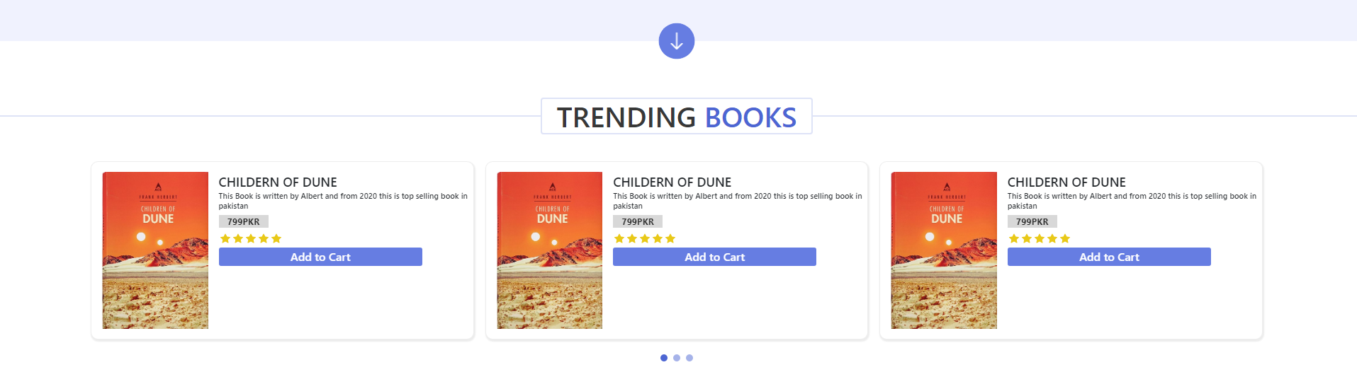



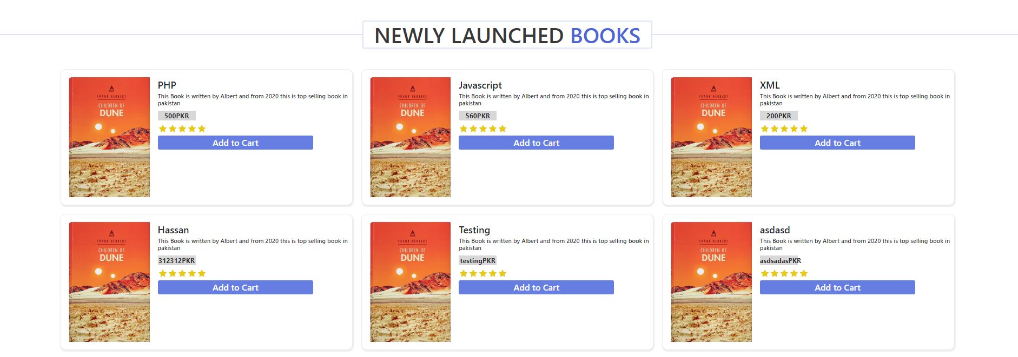

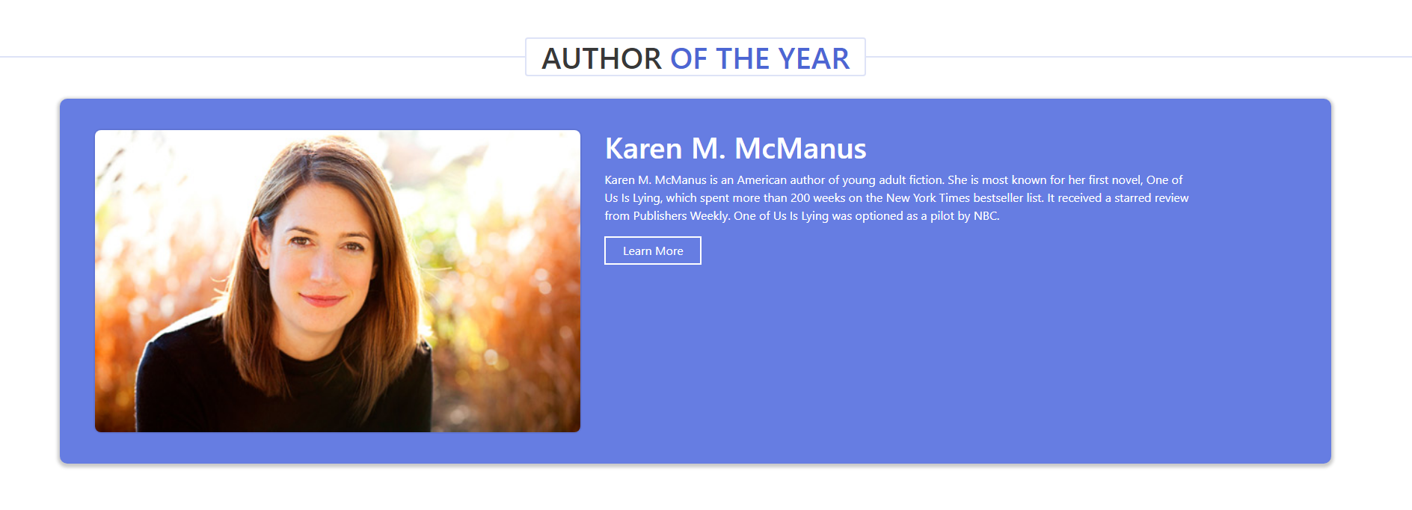

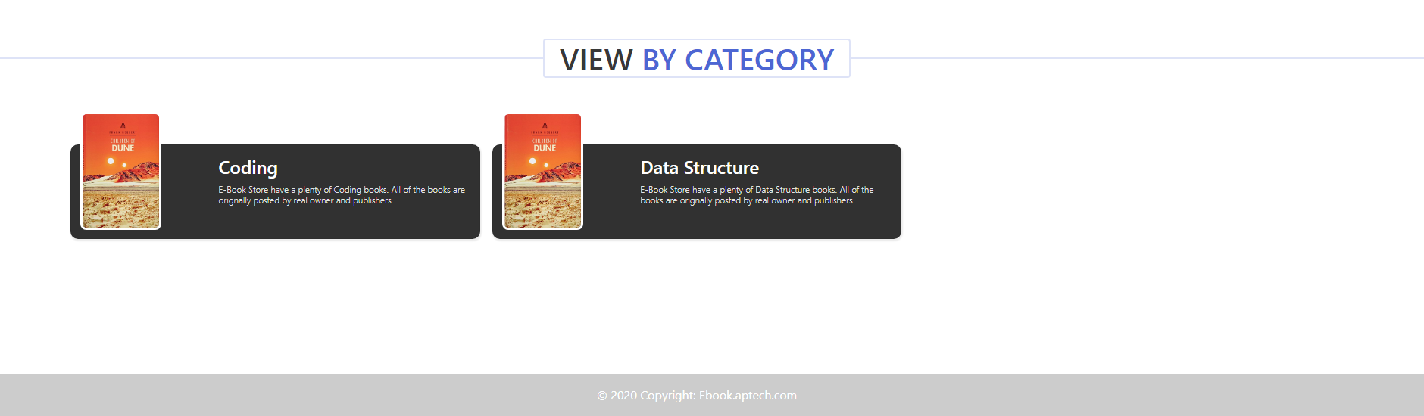

**Books Section Page**

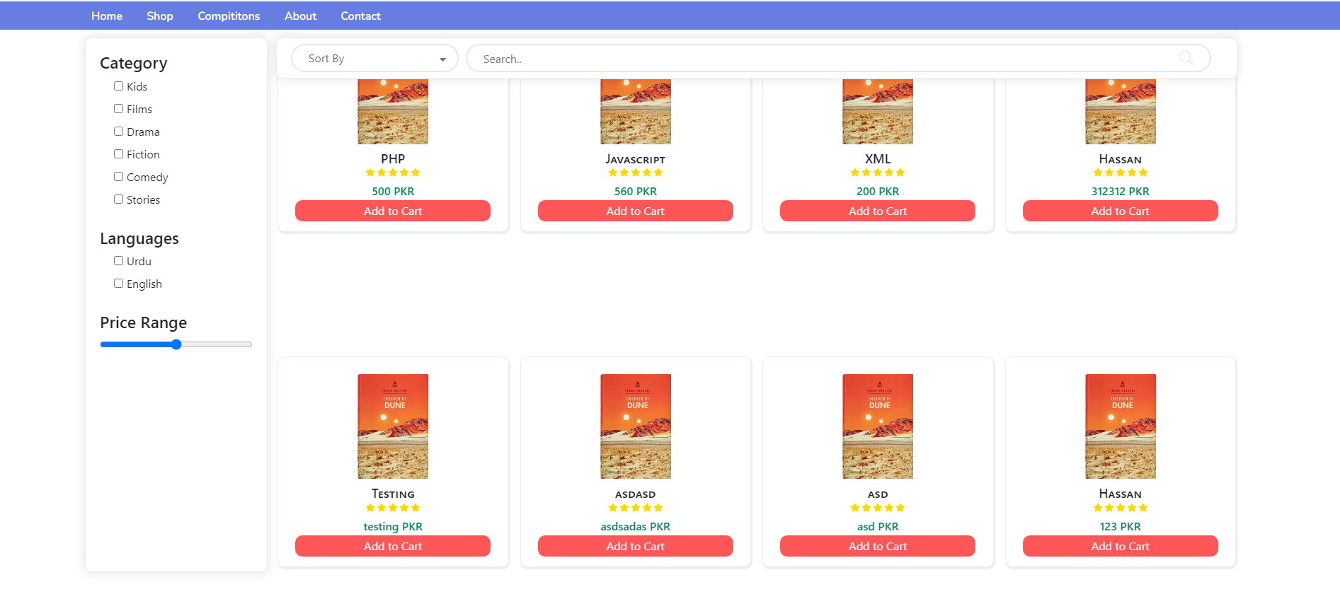

**Add to Card Page**

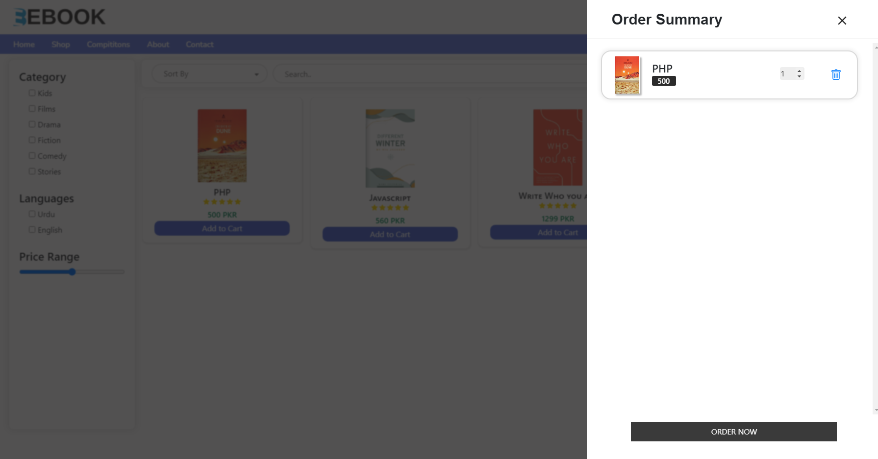

**Order Page**

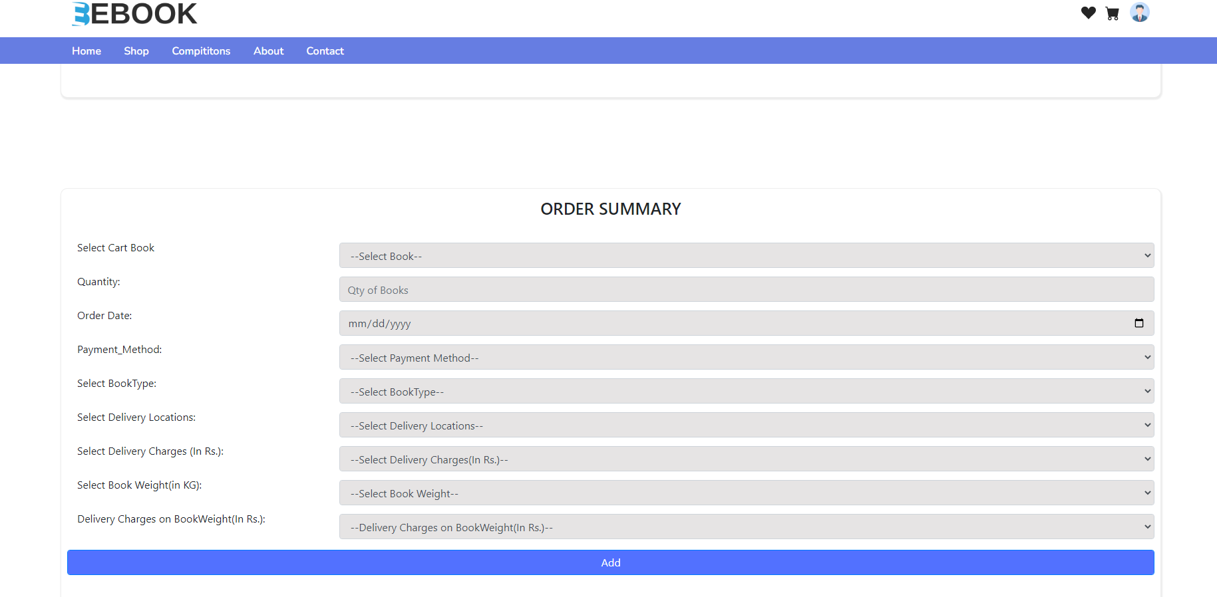

**Order Summary**

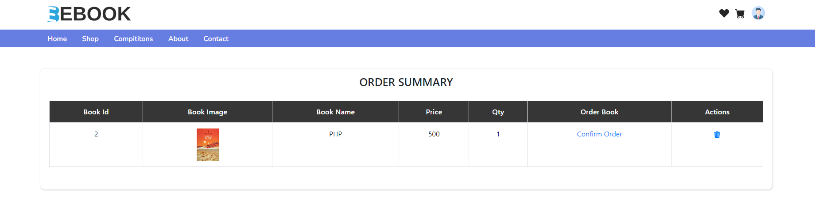

**Competition Page**

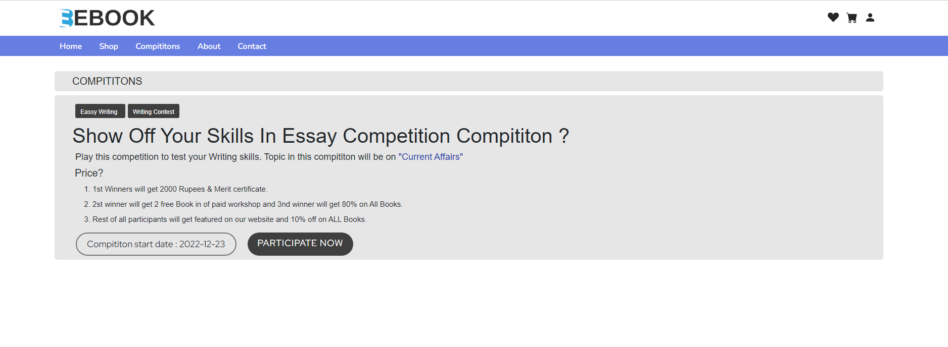

**About Us Page**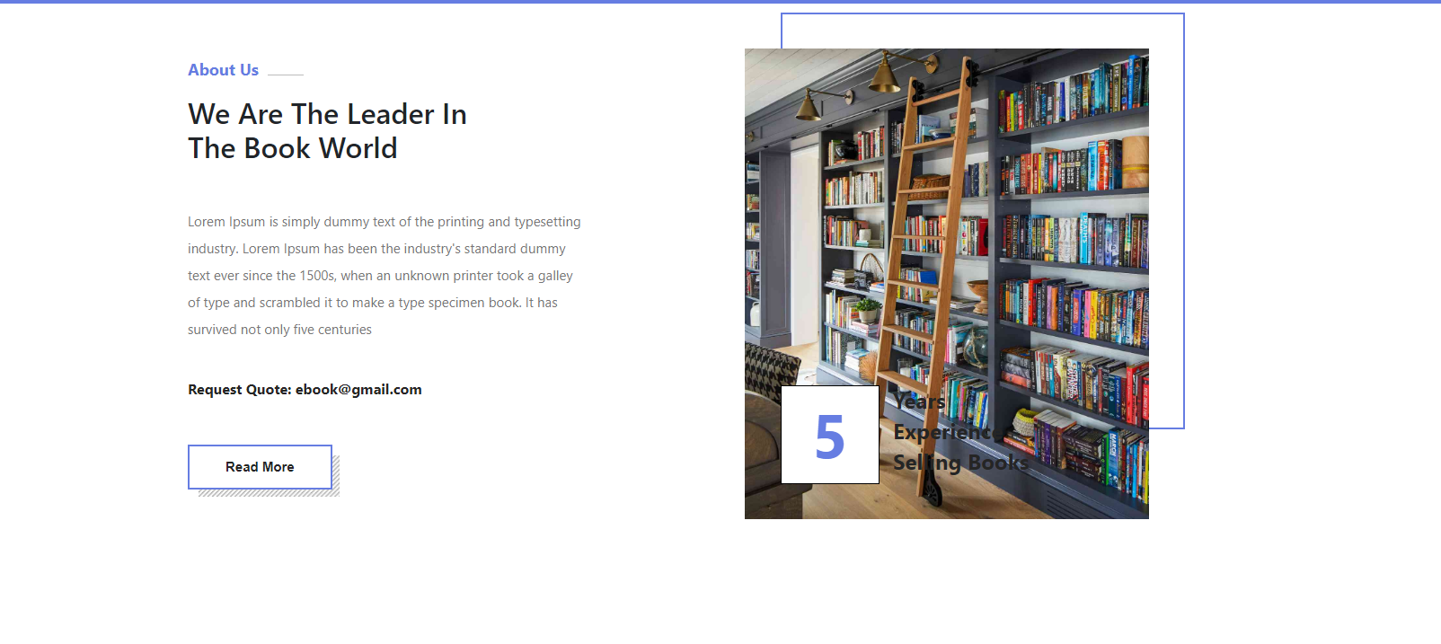

**Contact Us Page**

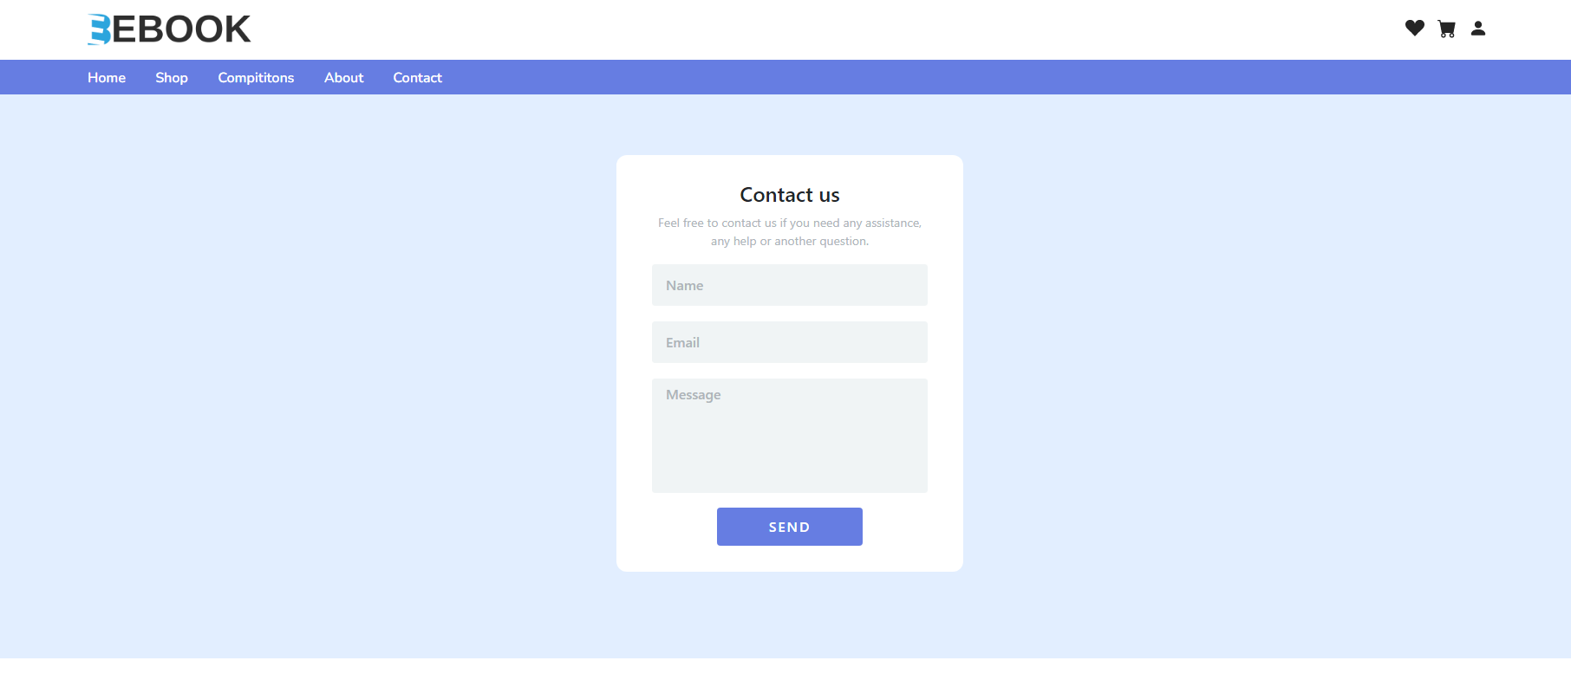

**Sign Up Page**

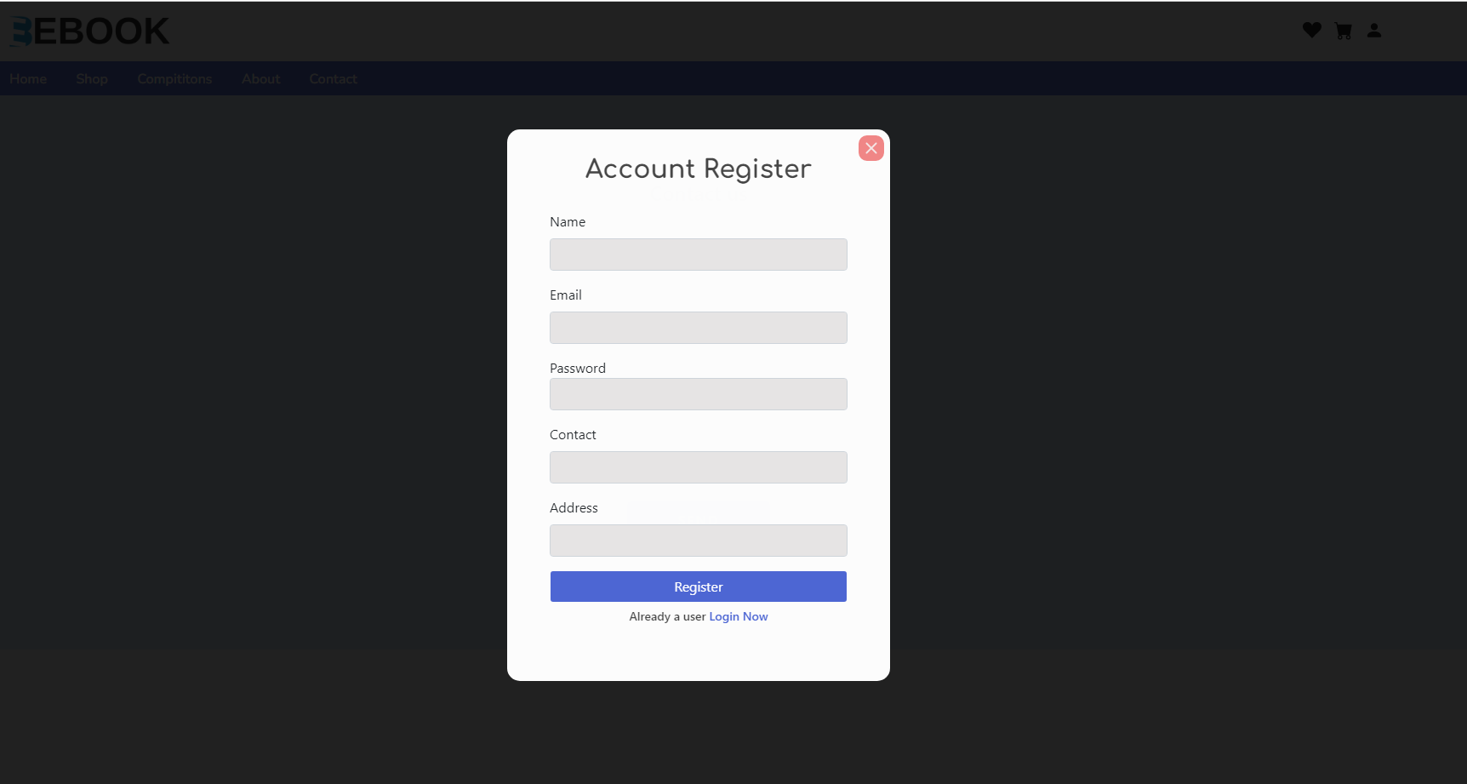

**Sign In Page**

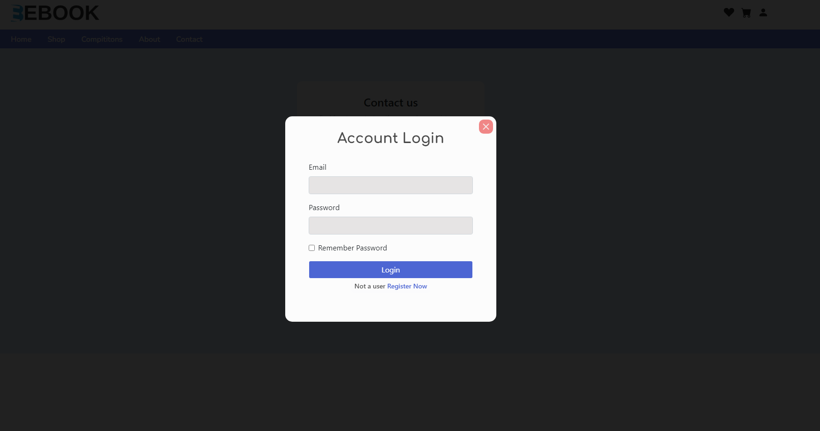

**Admin Panel**

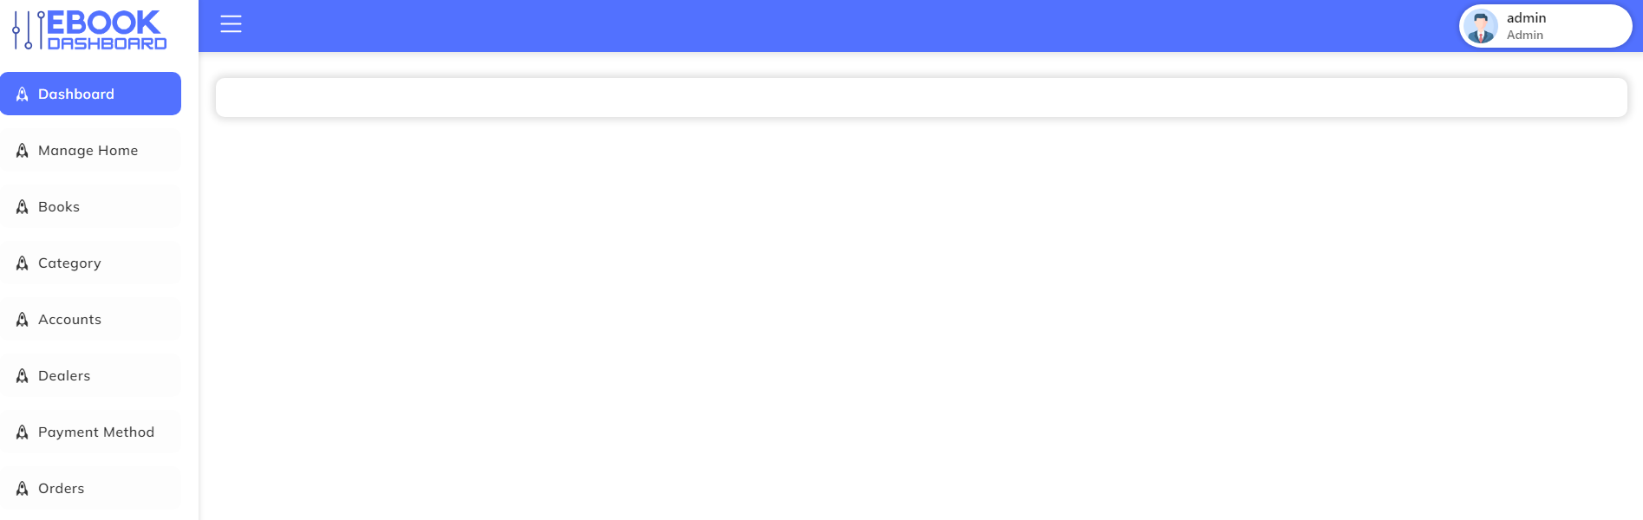

**Books**

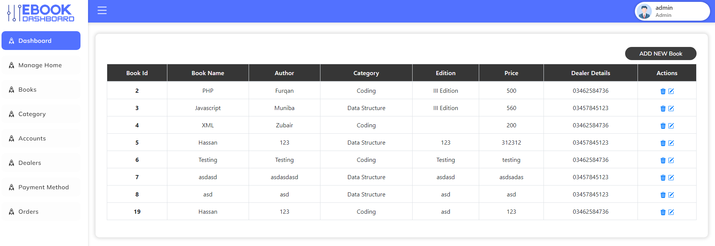

**Manage Category**

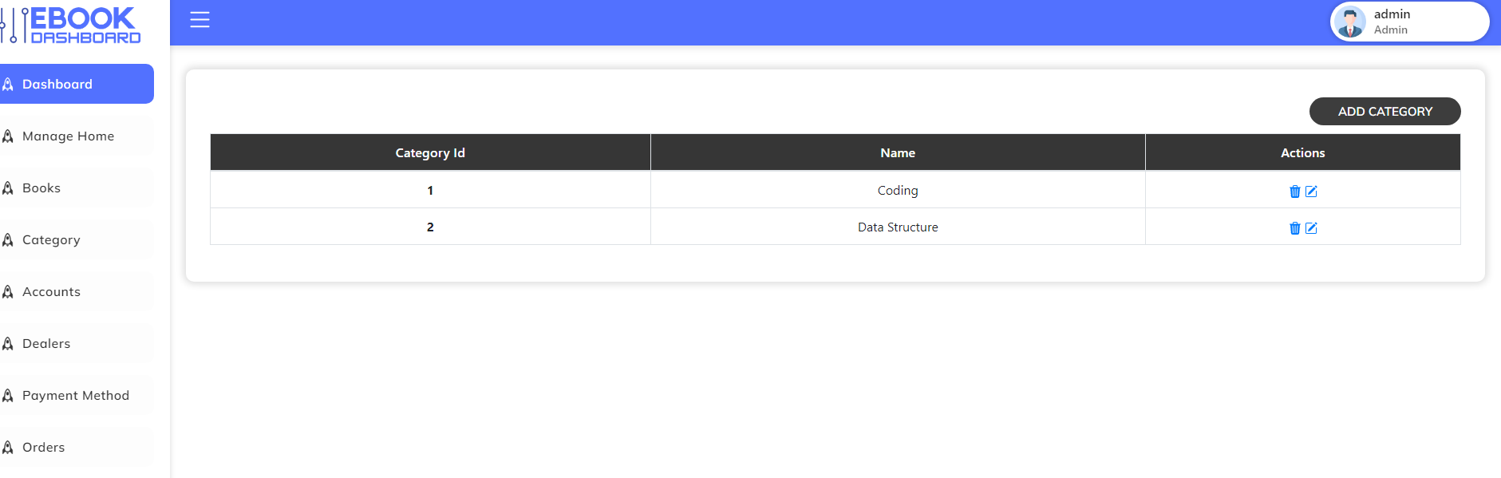

**Add Category**

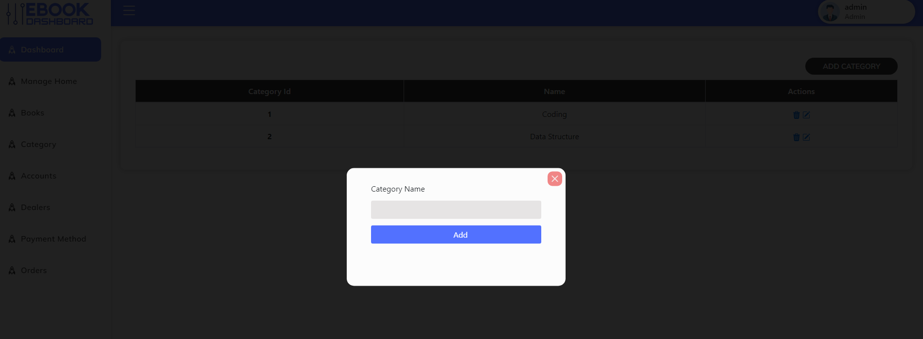

**Users Accounts**

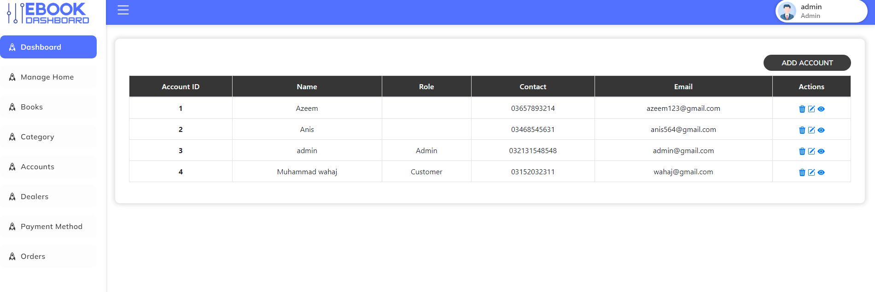

**Dealers Table**

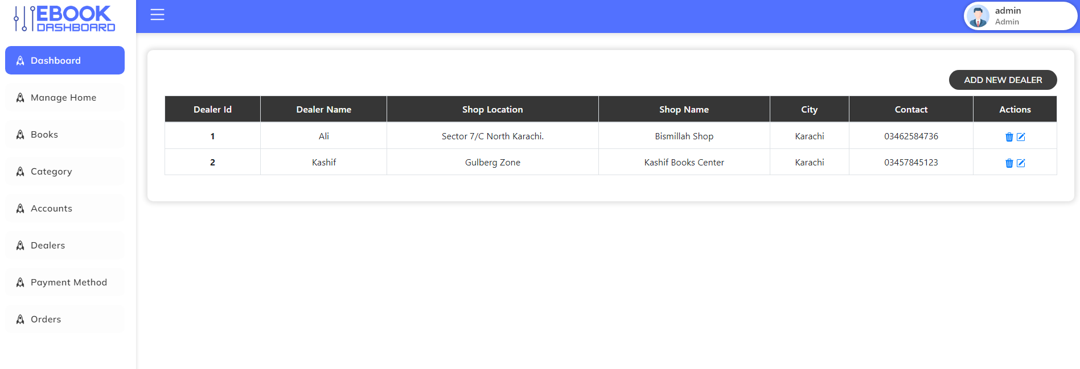

**Payment Method**

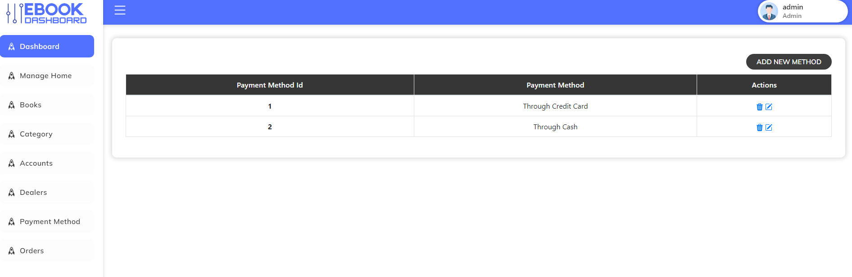

**Add Books**

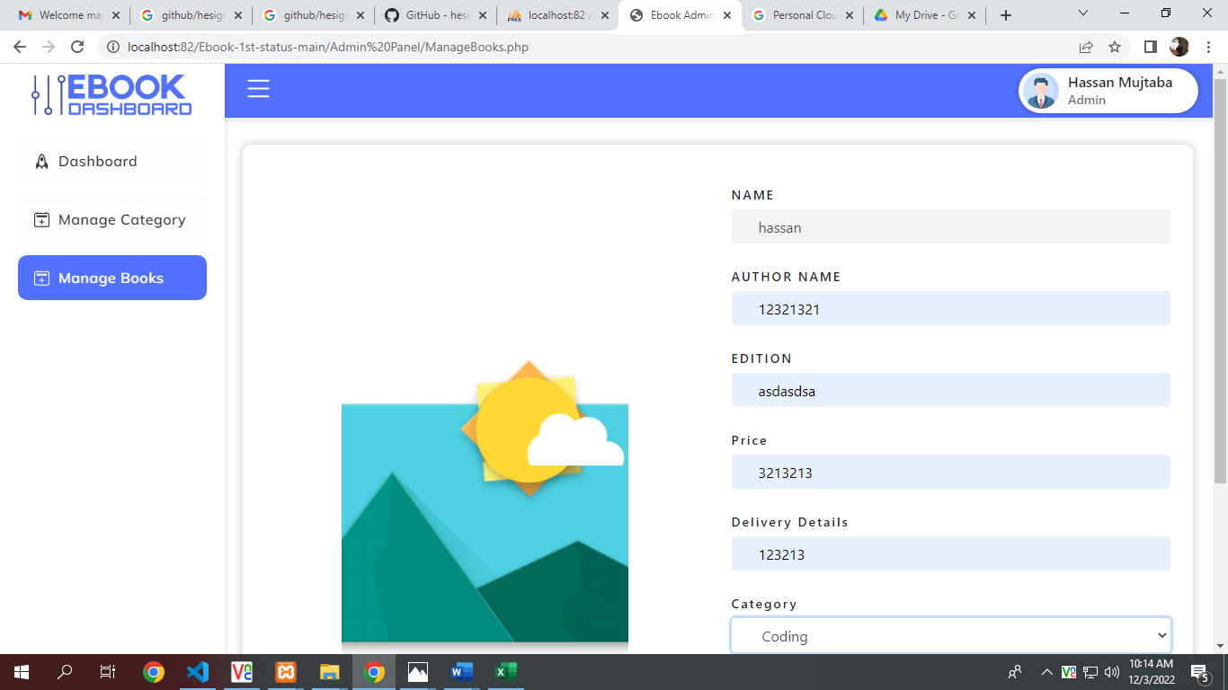

**Manage Orders Table**

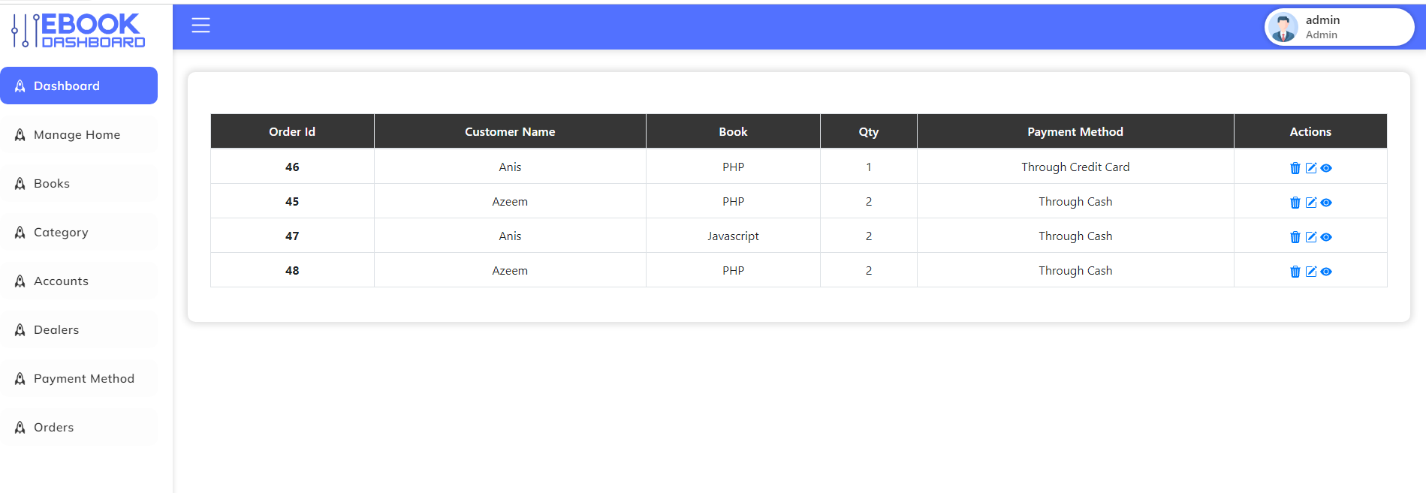

**Add category**

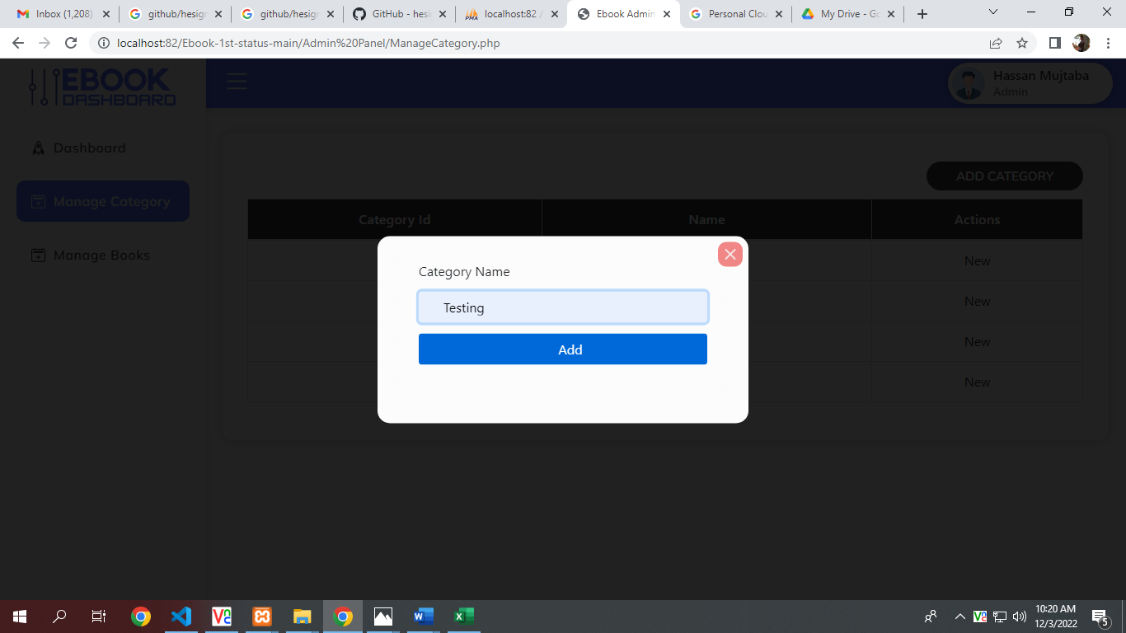

**Competition**

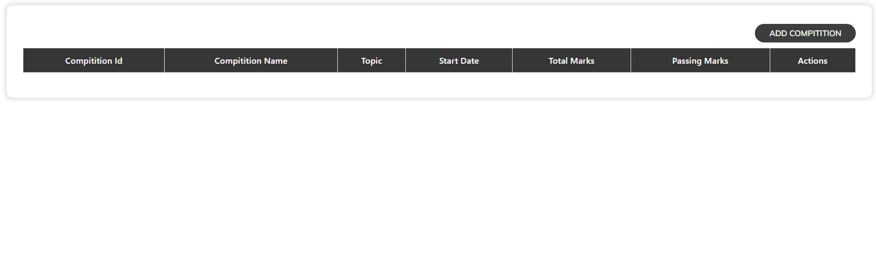

**Competition Winner**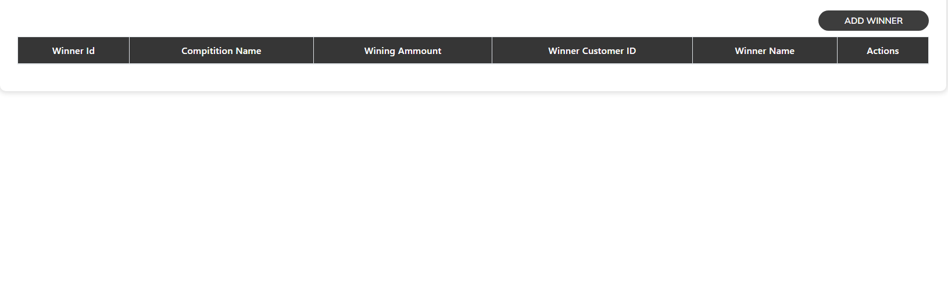

**Book Type**

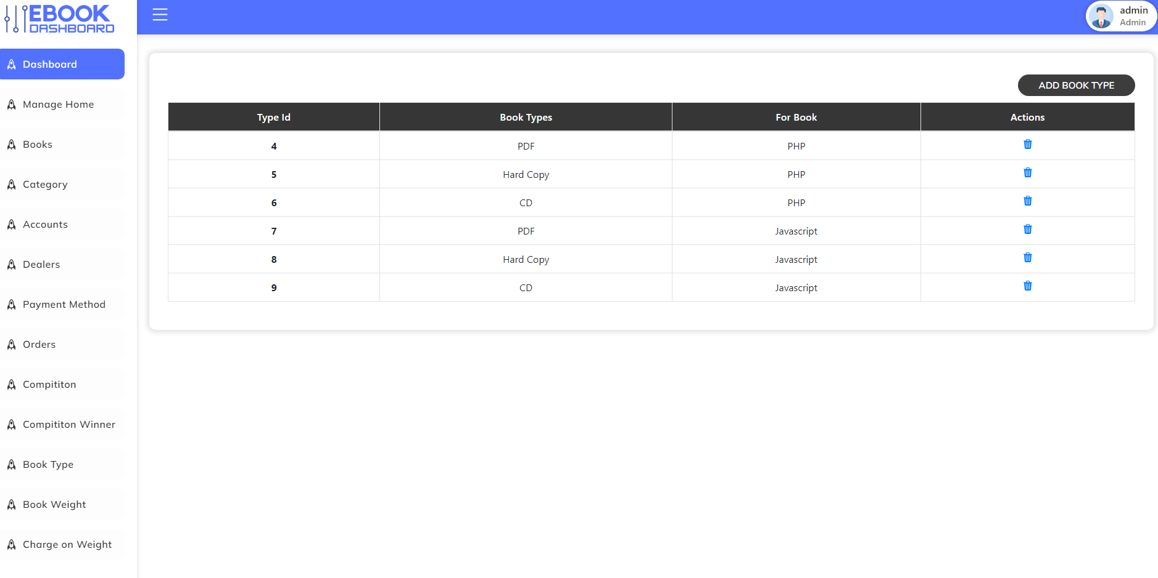

[**Book Weight**](http://localhost/Eproject-main/Eproject-main/Admin%20Panel/Booksweightmain.php)

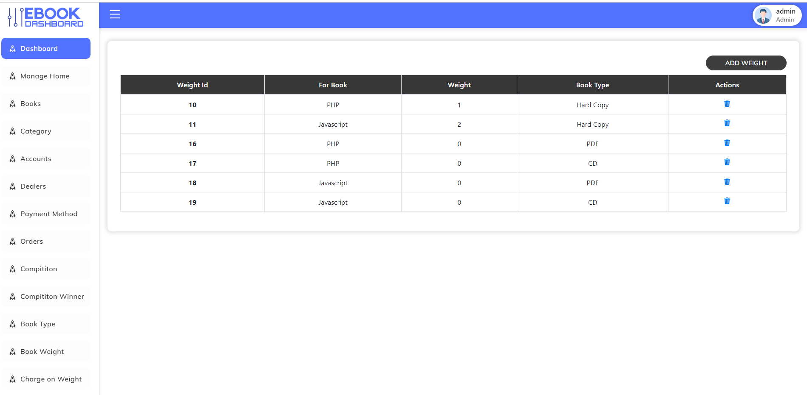

[**Charge on Weight**](http://localhost/Eproject-main/Eproject-main/Admin%20Panel/Booksweightmain.php)

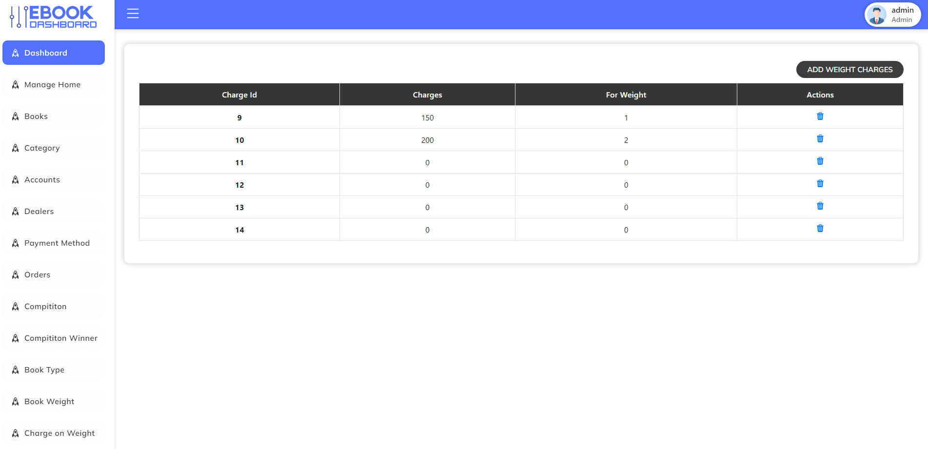

[**C**](http://localhost/Eproject-main/Eproject-main/Admin%20Panel/Booksweightmain.php)**ustomer Invoice**

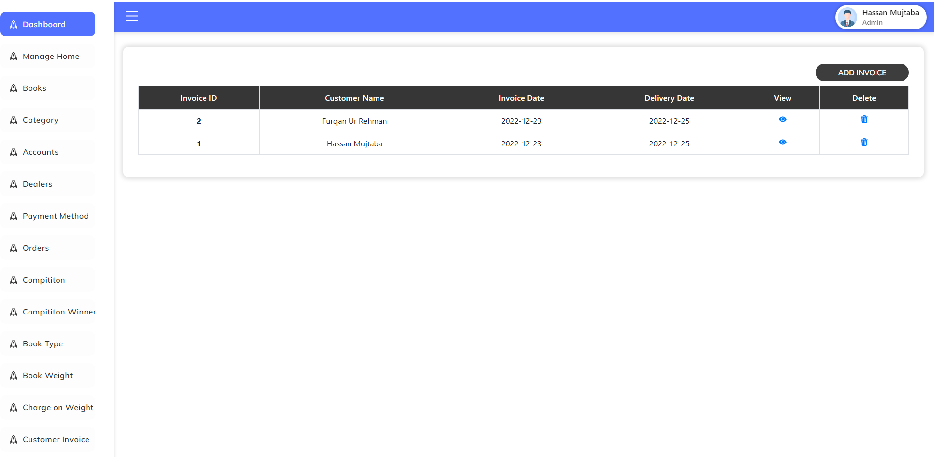

**“Database”**

**Books Table**

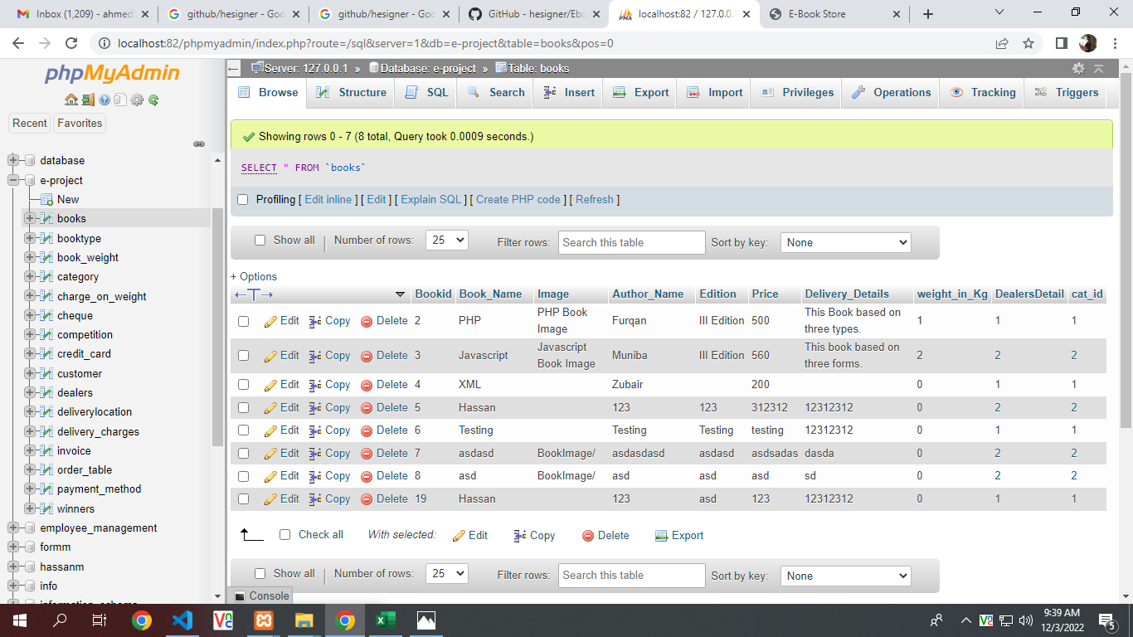

**Book Type Table**

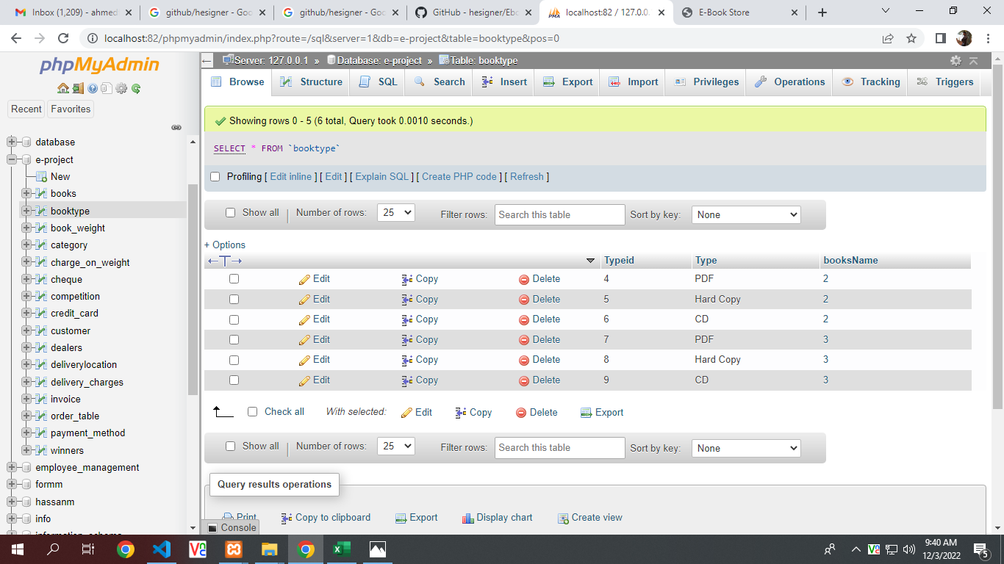

**Book Weight Table**

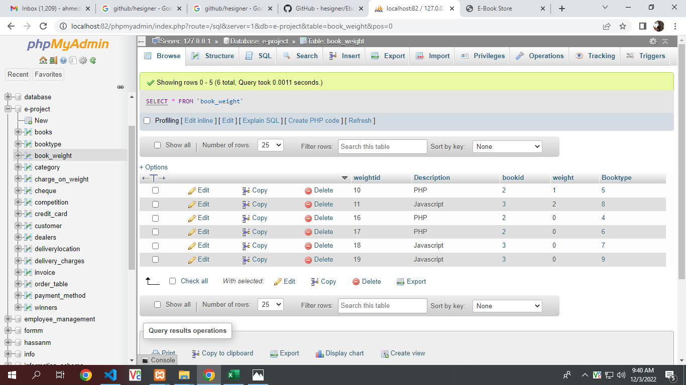

**Category Table**

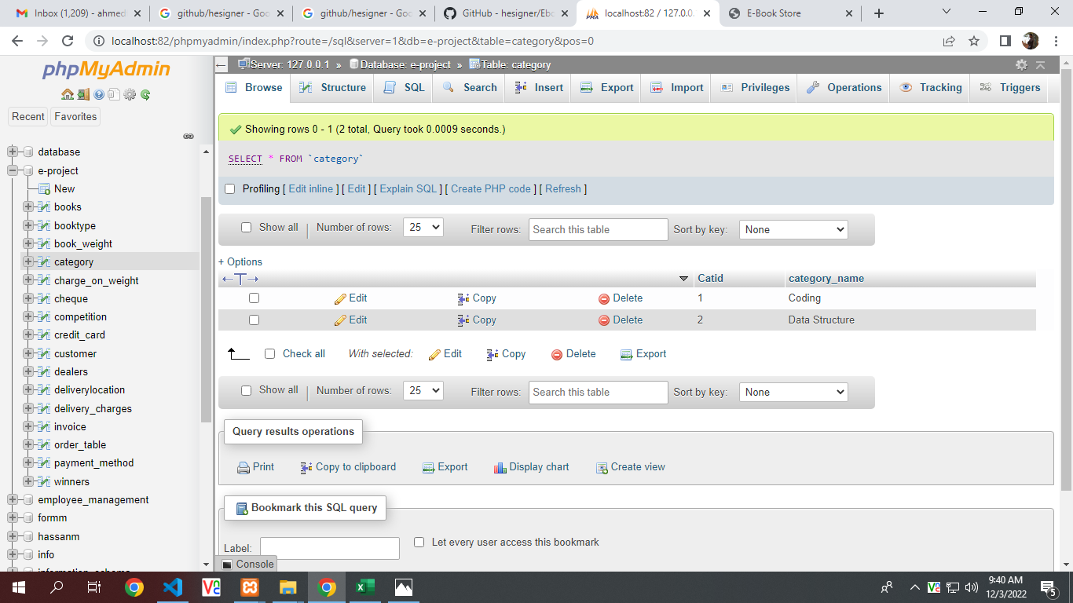

**Charge on Weight Table**

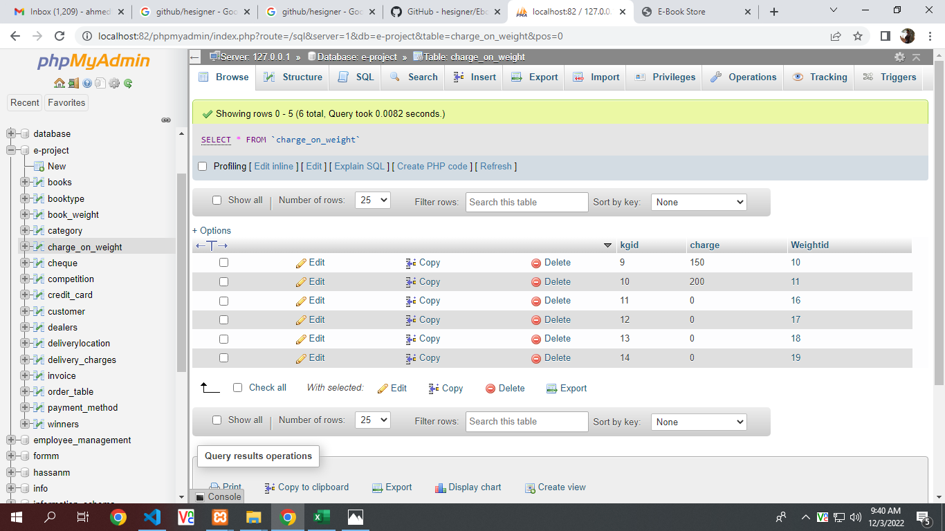

**Cheque Table**

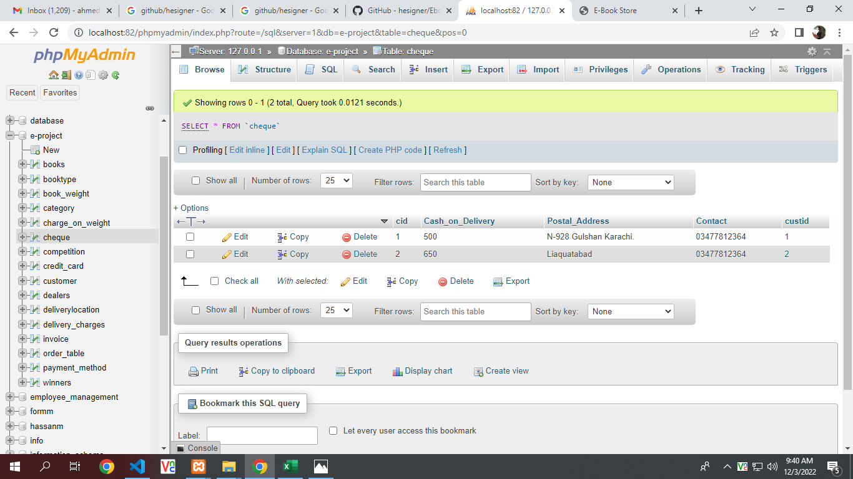

**Credit Card Table**

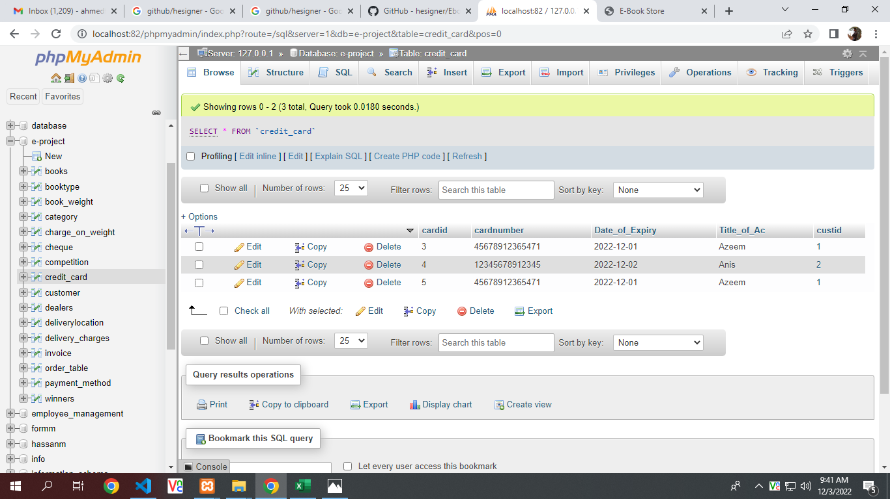

**Customer Table**

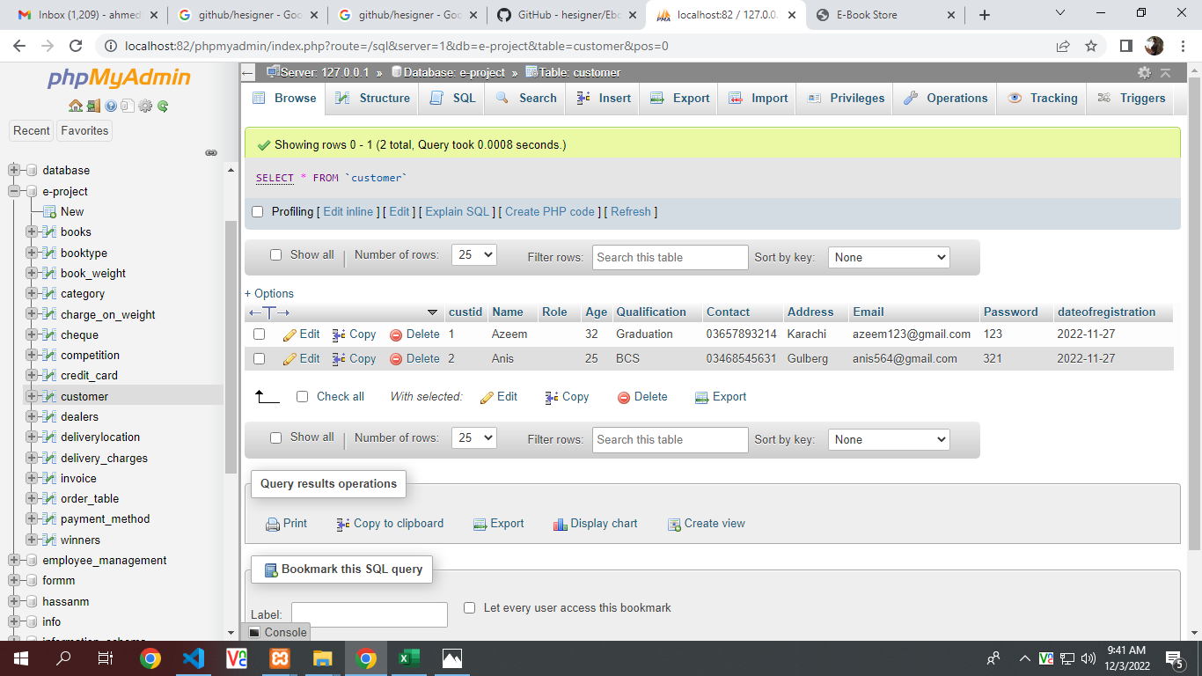

**Dealers Table**

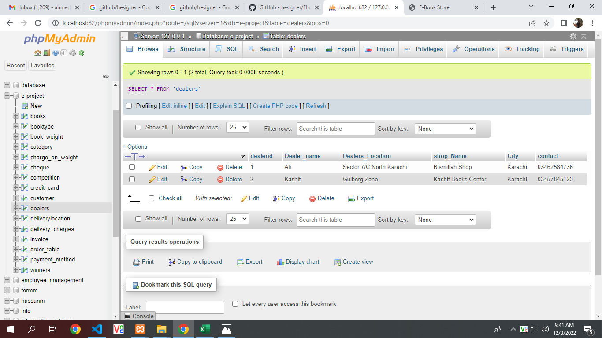

**Delivery Location Table**

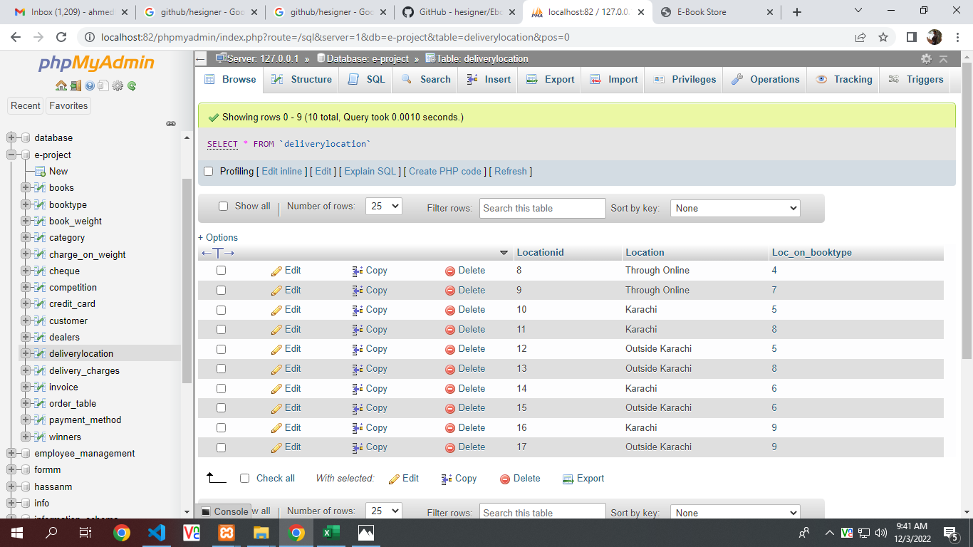

**Delivery Charge Table**

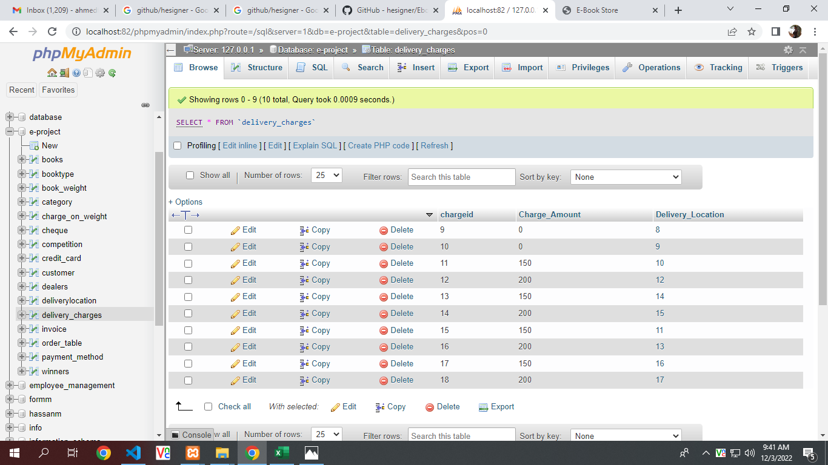

**Order Table**

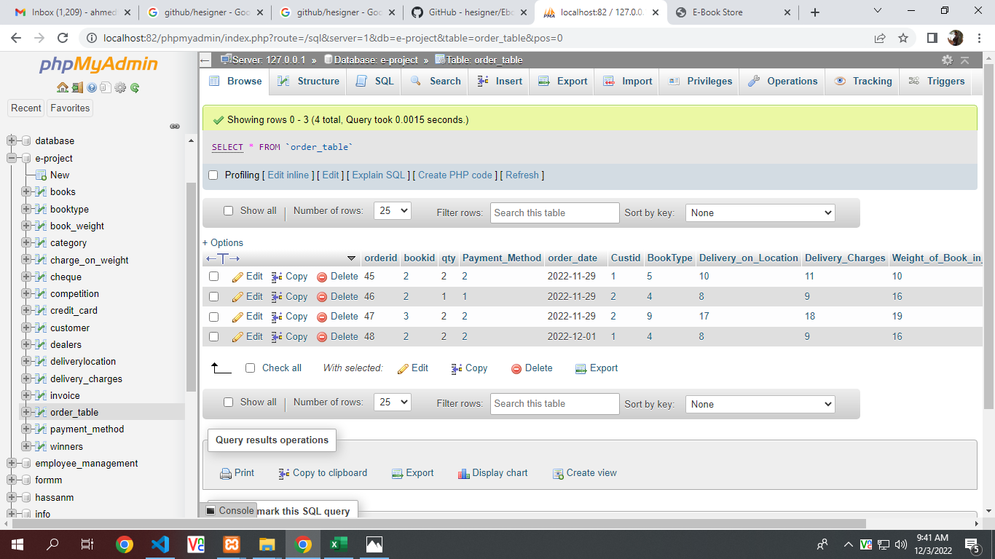

**Payment Method Table**

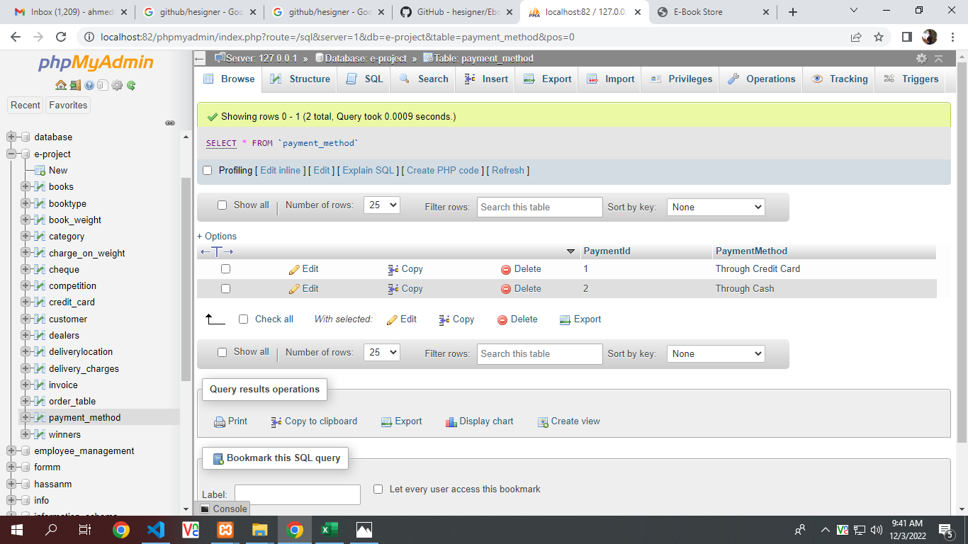

**Database Flow Chart**

